We used the models architectures mentioned in this [paper](https://www.researchgate.net/publication/381125640_A_Comparative_Study_of_CNN_ResNet_and_Vision_Transformers_for_Multi-Classification_of_Chest_Diseases) and conducted a comparative study on a new dataset to test their performance across a different medical imaging classification task. The new dataset we chose is (give a brief about the dataset including its size and add some samples from the website). We trained the CNN and ResNet models mentioned on the original paper on this dataset and got the following results:

1. CNN: 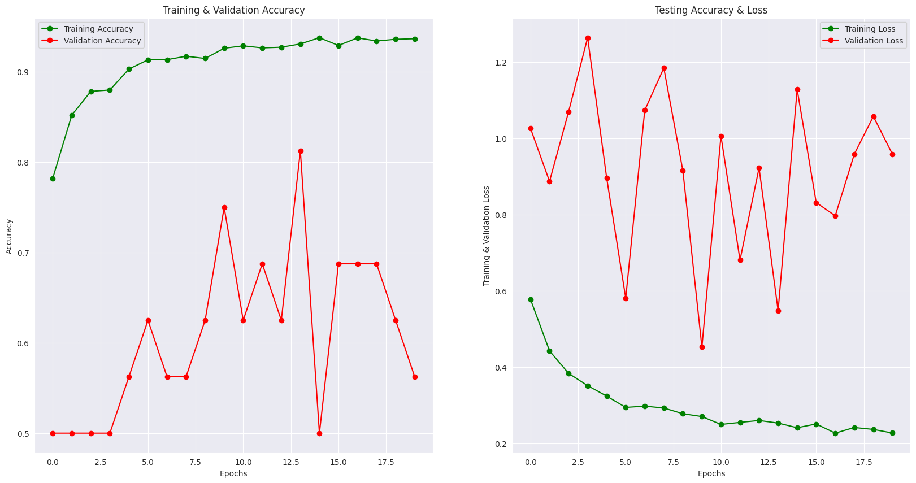

(Training and validation accuracy and loss graphs)

Classification report:  
 precision recall f1-score support

Pneumonia (Class 0) 0.92 0.89 0.91 390

Normal (Class 1) 0.83 0.87 0.85 234

accuracy 0.88 624

macro avg 0.88 0.88 0.88 624

weighted avg 0.89 0.88 0.89 624

Confusion Matrix:  
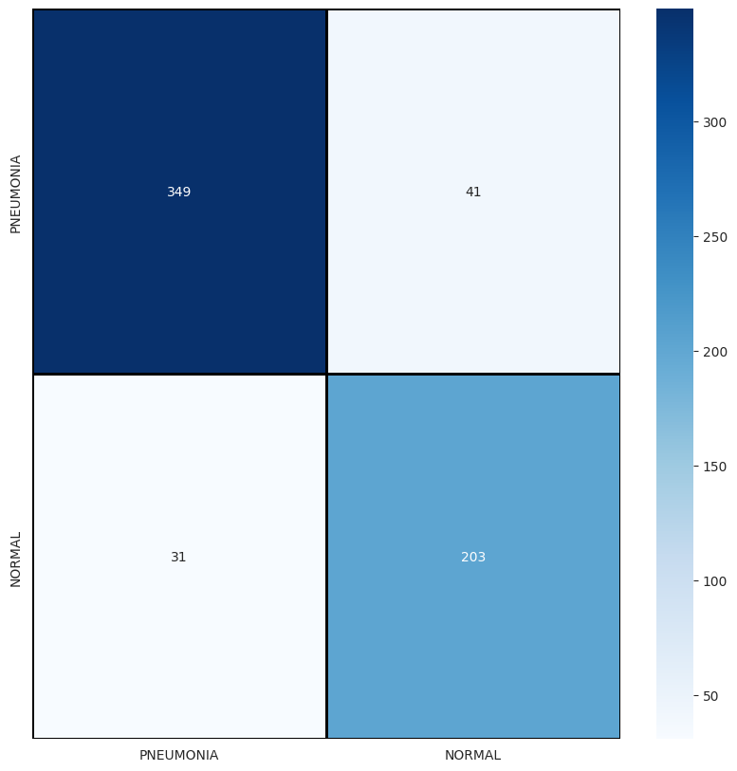

1. ResNet:

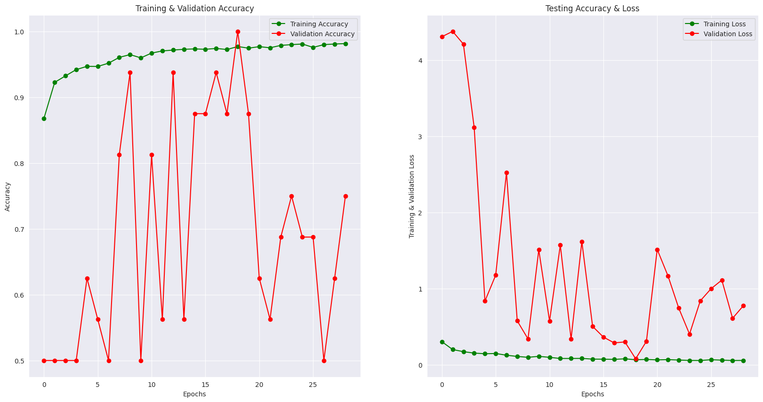

Classification report:

precision recall f1-score support

Pneumonia (Class 0) 0.96 0.87 0.91 390

Normal (Class 1) 0.81 0.94 0.87 234

accuracy 0.90 624

macro avg 0.89 0.90 0.89 624

weighted avg 0.90 0.90 0.90 624

Confusion Matrix:

